**Figure 1. A)** Workflow for the calculation of the different connectivity measures from fMRI resting-state data. After a standard pre-processing pipeline, a parcellation covering the whole-brain is applied (AAL) to extract BOLD time series for 116 ROIs.. Here we consider two versions of functional connectivity: corrFC corresponding to the Pearson correlation of pairs of time series, and covariances with and without 1 sample time shift, FC1 and FC0, respectively; see text for details. **B)** Whole-brain network model and estimation procedure to interpret fMRI data. The anatomical structure obtained using diffusion-weight imaging (DWI) determines the skeleton of the inter-region connectivity, referred to as SC (bottom). The local fluctuating activity (with covariance Σ) is shaped by the recurrent EC to generate correlation patterns at the network level (FC). The estimated EC and Σ correspond to the model that best reproduces the empirical FC. C) From each fMRI session we calculate the EC and FC matrices. EC links are extracted by applying the SC binary mask and transformed into a vector of 4056 elements. In the case of FC only the edges from the lower triangle matrix are used, giving a 6670-element vector.

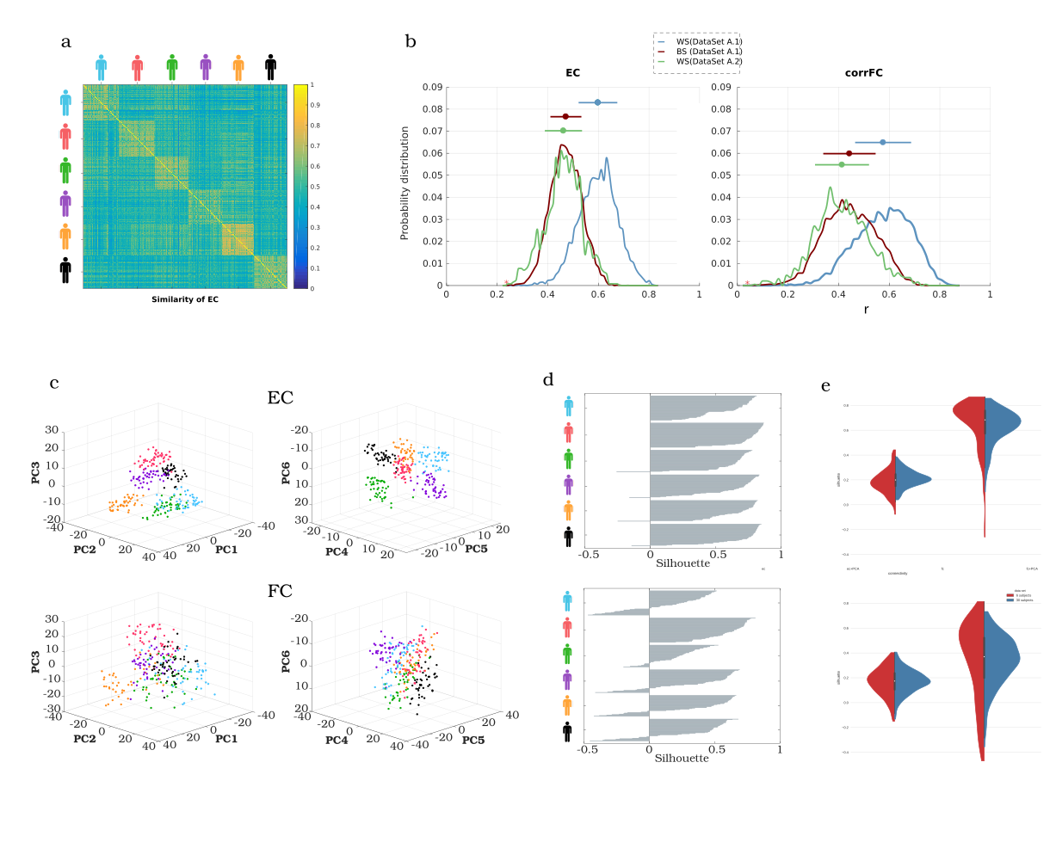**Figure 2. Within- vs. between-subjects similarity for EC/FC and degree of clustering.** **A)** The WS and BS similarity is calculated as the Pearson correlation coefficient between every pair of connectivity matrices –vectorized lower triangle- from the same and different subjects respectively. **B)** Probability distributions of WS and BS similarity. WS similarity (in blue) has been calculated from the dataset A1. The BS curves have been obtained from dataset A1 (in red), computing the correlation between all the possible combinations of 6 matrices, one per subject, and repeating for 1000 times; as well as from dataset A2 (in green). **C)** Visualization of the six first components after applying PCA to all the EC and FC data from dataset A1. Each point corresponds to one scanning session. **D)** Silhouette coefficient of each point in C) that measures the degree of clustering –ranging from -1 to 1- in the same six PC (cohesion intra-cluster and separation betwee clusters). Points in EC have larger and more positive values of silhouette than points in FC. **E)** Violin plot of the EC and FC silhouette coefficients before and after applying PCA to the full datasets A1 (6 subjects, in red) and B (30 subjects, in blue).

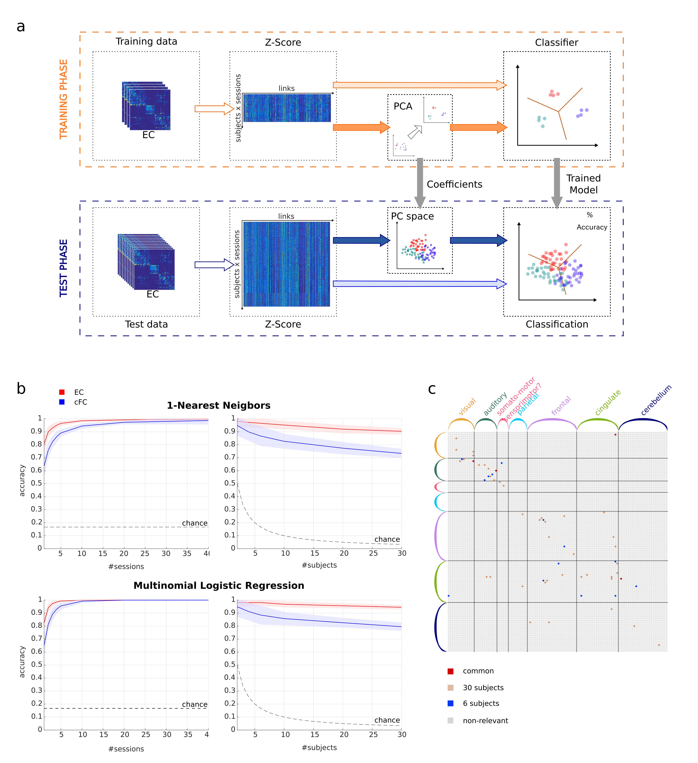**Figure 3. Classification performance of EC and FC depending on sessions and subjects. A)** Classification pipeline used to assess the performance on subject identification with EC and FC. The full set of fMRI sessions was split into two groups: a train set and a test set. We applied z-score standardization at the session level to all the matrices. We trained each classifier - with and without applying PCA - and evaluated the classification accuracy on the test set. **B)** Performance of both 1NN and MLR classifiers varying the number of sessions per subject used on the train set on dataset A1 (6 subjects-50 sess), as well as varying the number of subjects, using one train session per subject on dataset B (30 subjects-10 sess). Mean and standard deviation were calculated for 100 repetitions with different training and test sessions randomly chosen. **C)** Connectivity links from EC that support the classification between subjects in both datasets (A1 in blue, B in brown, common links in A1 and B in red). We applied recursive feature elimination (RFE) as the extraction technique to find the most relevant connections between ROI in order to discriminate between subjects.

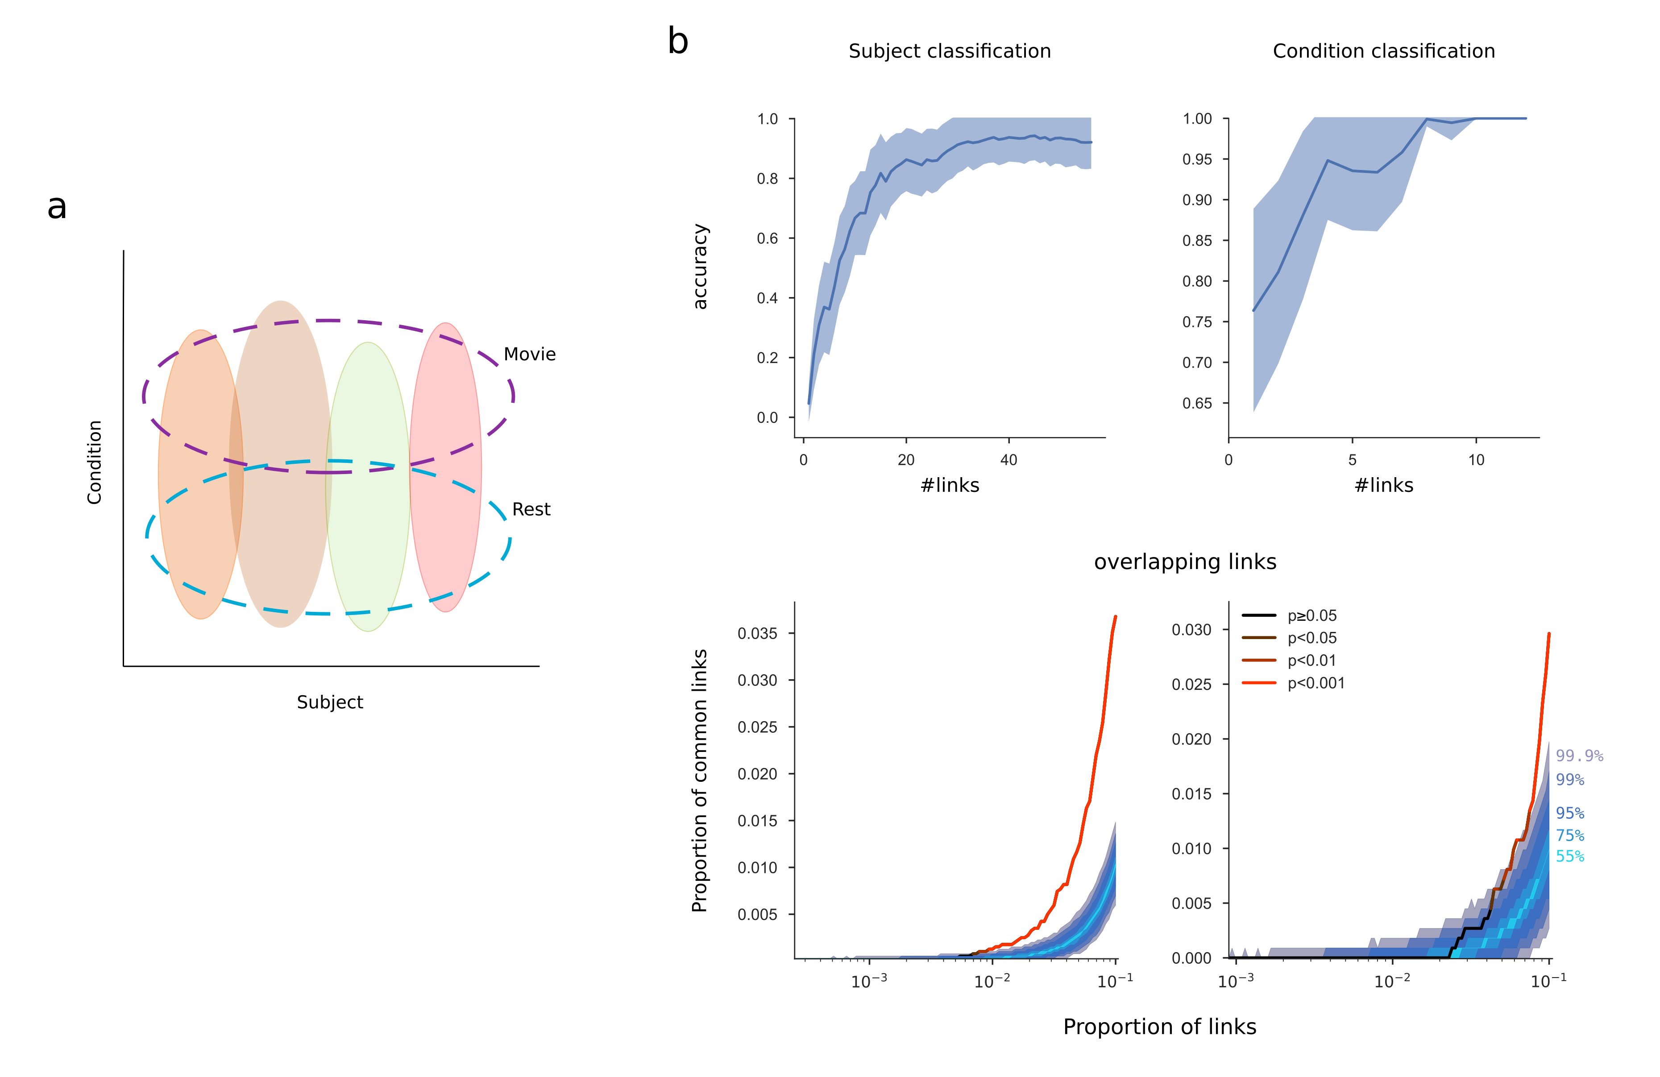**Figure 4. Bi-dimensional discrimination of subjects and conditions: extraction of the links that are driving the classification. A)** Scheme of the bi-dimensional approach used for identifying both the signature of each condition and the fingerprint of the subjects. **B)** Classification accuracy on subjects and conditions (resting vs. free viewing) on dataset C depending on number of links used. The performance is computed with a MLR classifier and X train sessions (signal length) per subject.Links from EC are included in the classification pipeline following after being sorted by the RFE technique in decreasing relevance for the classification. **C)** No sé explicar estas figuras…. :/

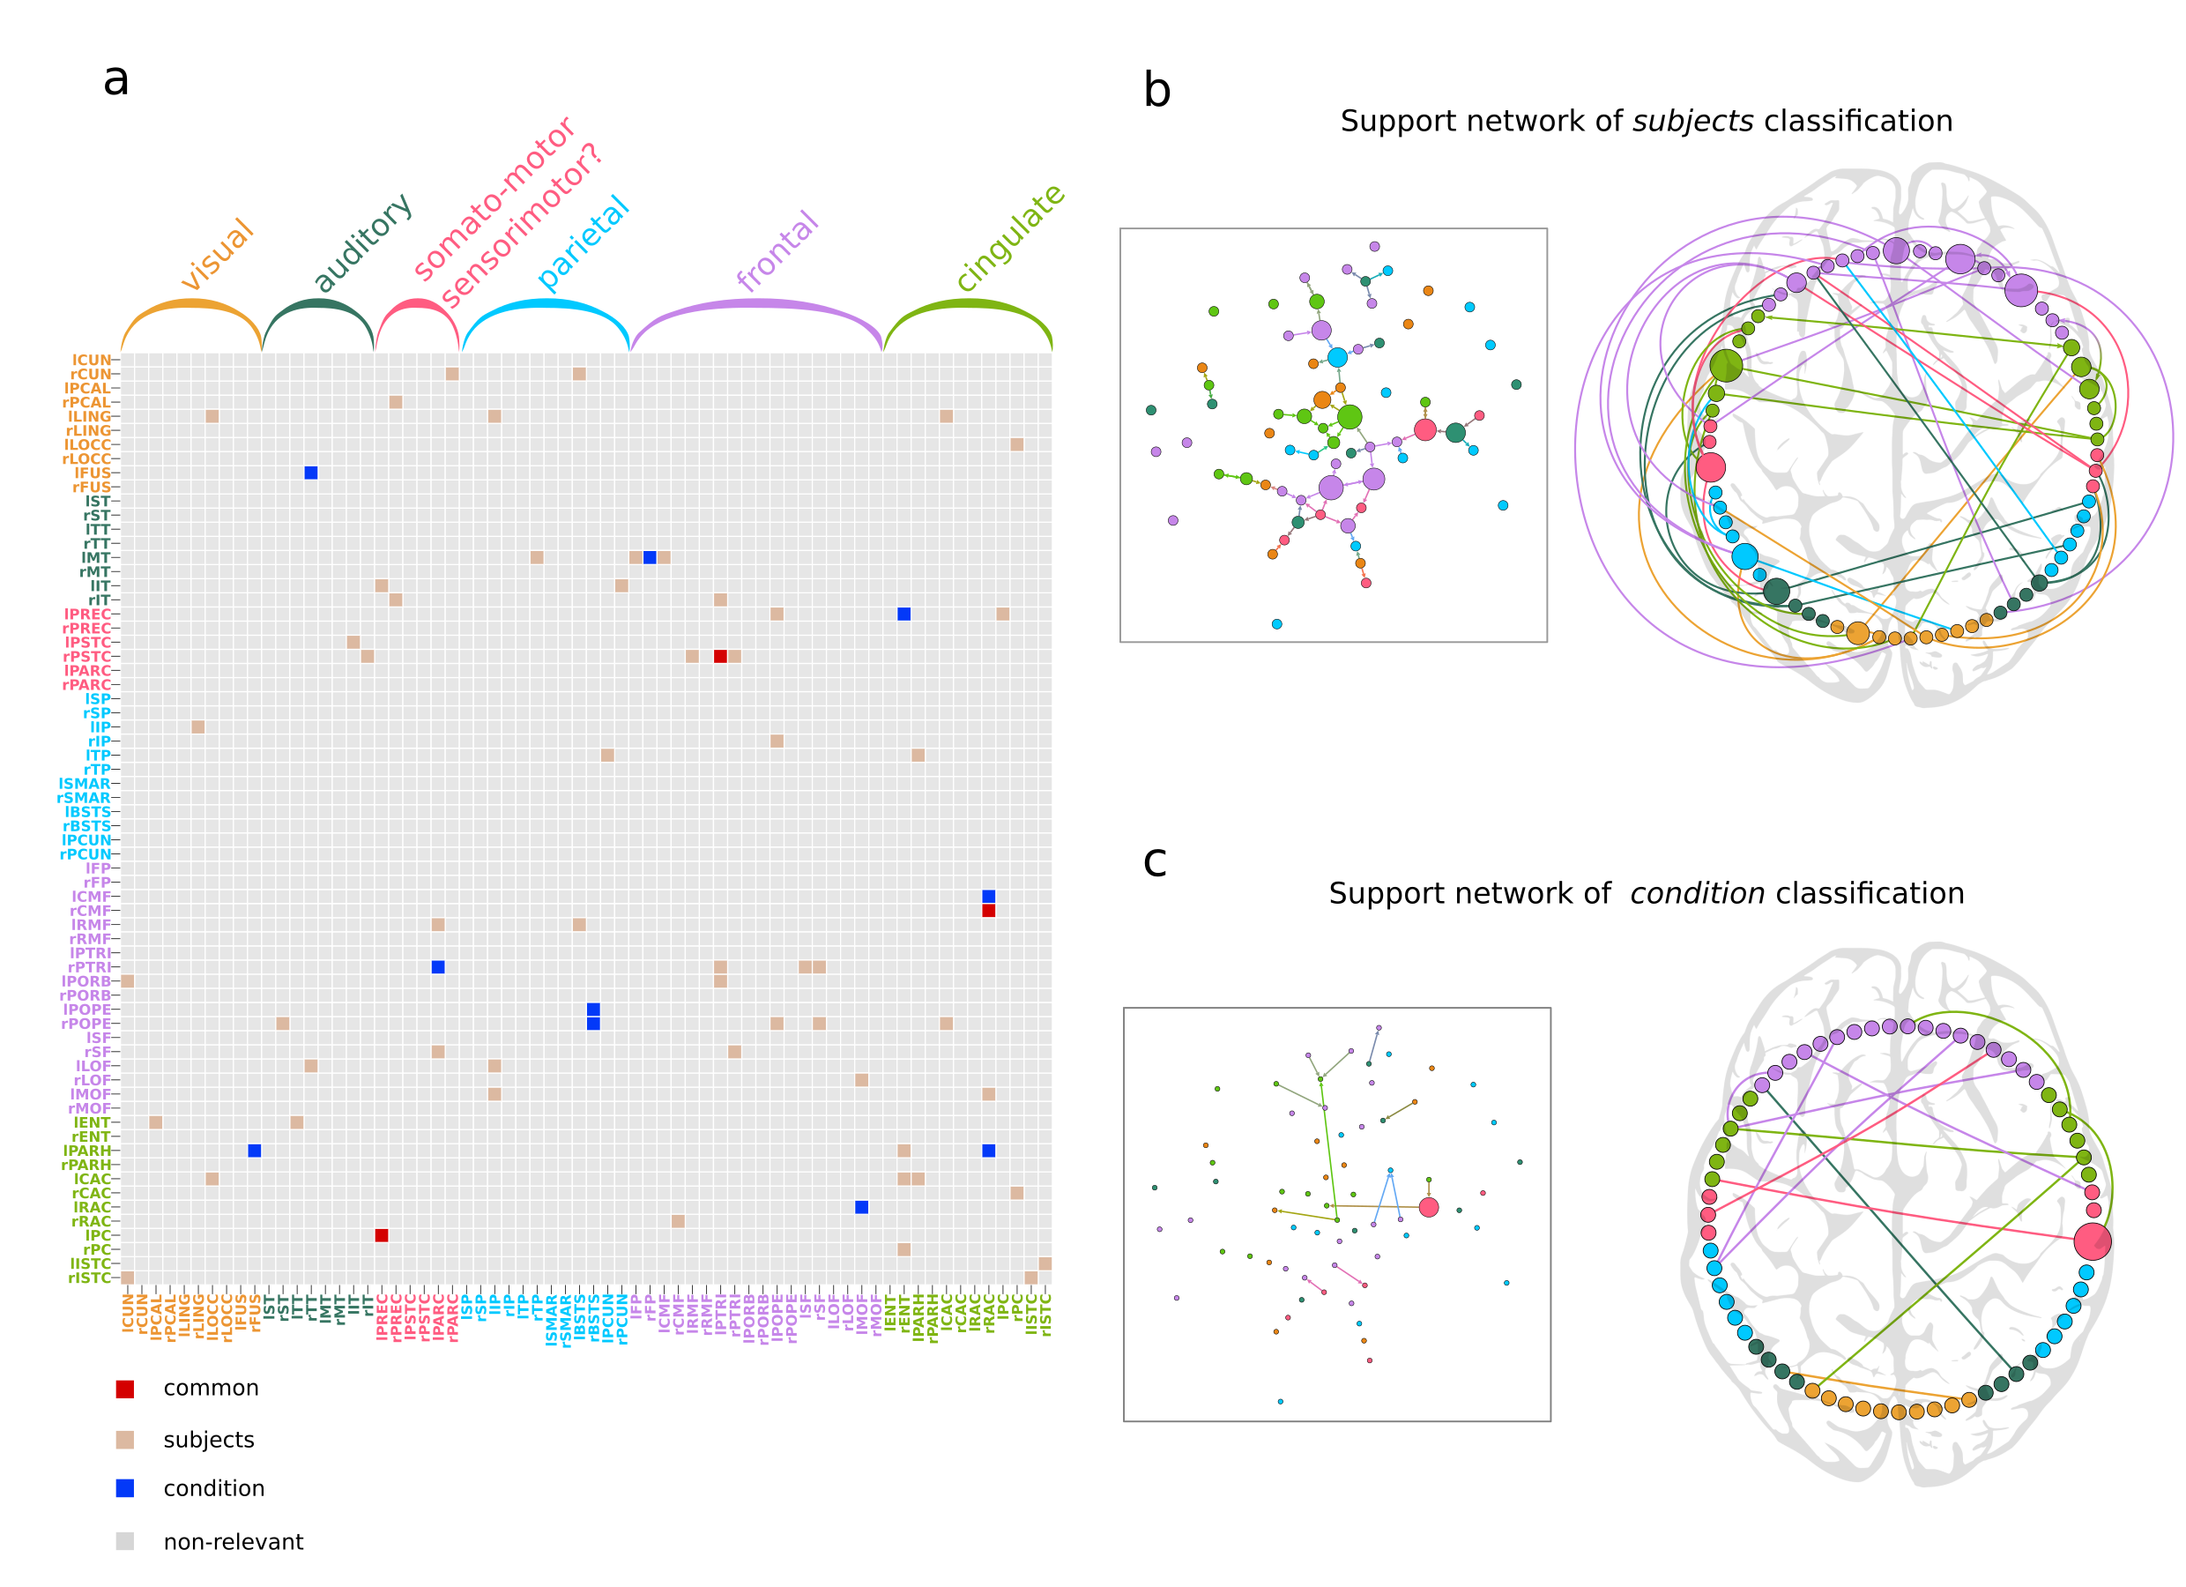

**Figure 5. Support networks of subjects and condition classification. A)** Most discriminant connectivity links from EC that support the classification between subjects and conditions from dataset C (X links for subject classification in brown, X for condition classification in blue, 3 common links for both kinds of classification in red). RFE was applied to find the most relevant connections between ROI for bi-dimensional discrimination between subjects and conditions. **B)** Graph plot of the X most discriminant EC links supporting the classification of subjects. The size of each node is related to its centrality in the extracted network. The most central regions are located mainly in the frontal cortex. The circos plot shows the asymmetry and lateralization of the network, with more links located in the left hemisphere (confirmar). Links that are inside the circle correspond to contralateral connections, while links outside the circle are the ipsilateral connections. **C)** Graph and circos plot of the X extracted links that support the classification between conditions (resting vs. free viewing). Fewer links are required to reach high accuracy in the discrimination between conditions (quizá en este caso no tiene mucho sentido representar la centrality porque solo hay un nodo más grande y el resto se ven demasiado pequeños).